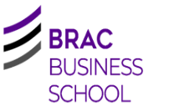
Cover Sheet for Group Assignments

Name: Samin Tanzim Rahman |  | Student ID: 24305019
Name: Samiha Arefin |  | Student ID: 24305042
Name: Mehedi Hasan Rowdro |  | Student ID: 24101226
Name: Hazera Jahan Ratri |  | Student ID: 1000055744
Name: Samira Sultana |  | Student ID: 25104007
Name: Chëñchö Tsħëřiñġ |  | Student ID: 21201833
Course name: BUS102: Business - Basics, Ethics And Environment
Lecturer name: Noshin Anjum Chaiti (NAC)
Word Count (tables, charts, pictures references appendices and group learning report are not included): 2000
PLAGIARISM  Plagiarism is the presentation by a student of an assignment that has been copied in whole or in part from another student’s work, or from any other source (e.g. published books or periodicals or internet sites) without proper Acknowledgment in the text. |  | CONSEQUENCES OF PLAGIARISM AND COLLUSION  In any case where a student has been involved in plagiarism or collusion, this will be reported to the Dean. Their assignments will not be checked and they will fail to be evaluated. It may be reported to Student Administration and recorded on the student’s academic file.

DECLARATION



By submitting this assignment to the BRAC Business School, BRAC University, we declare that this submission is our own work and does not involve plagiarism or collusion.

We give permission for our assignment to be scanned for electronic checking of plagiarism

Business Analysis Report
on
British American Tobacco Bangladesh (BATBC)

Title: Business Analysis of British American Tobacco Bangladesh Company Limited (BATBC)

Course: BUS102: Business—Basics, Ethics, and Environment
Submitted to: NOSHIN ANJUM CHAITI (NAC),
BBS, BRAC University
Submitted by:
SAMIN TANZIM RAHMAN
SAMIHA AREFIN
MEHEDI HASAN ROWDRO
SAMIRA SULTANA
HAZERA JAHAN RATRI
Chëñchö Tsħëřiñġ
Date of Submission: July 18, 2025

Table of Contents

Introduction ................................................................. 3 [ CT ]

BATB Corporate Structure ....................................... 3 [ MHR ]

Corporate Social Responsibility (CSR) .............. 3 [ MHR ]

Bonayan (Afforestation Program)

Probaho (Water Filtration)

Deepto (Solar Energy)

Disaster Relief and Support

SWOT Analysis ..................................................... 4

Strengths [ STR ]

Weaknesses [ STR ]

Opportunities [ SA ]

Threats [ SA ]

PESTLE Analysis .................................................... 6

Political [ SA ]

Economic [ SA ]

Social [ SA ]

Technological [ STR ]

Legal [ STR ]

Environmental [ STR ]

Strategic Recommendations ............................... 10 [ HJR & SS]

SWOT-Based Recommendations

PESTLE-Based Recommendations

Conclusion ........................................................... 12 [ CT ]

References ............................................................ 13

Introduction

One of the biggest global FMCG corporations in Bangladesh is British American Tobacco Company Limited (BATBC). Over the decades, BATBC has been playing an essential role in influencing the market as the corporations under BATBC focus on producing quality products and they are known to be the best business operations over time. The company is in Dhaka and has provided multiple job opportunities for the citizens. Moreover, its economic contribution in GDP has been remarkably high.
- Chëñchö Tsħëřiñġ

BATB Corporate Structure
British American Tobacco Bangladesh Company (BATBC) is a corporate business. It is a public limited company. As it is a PLC, it can get benefits like getting more capital for business by selling shares to the public. They are listed in Dhaka Stock Exchange as well as in Chittagong Stock Exchange. This opens them the opportunity of selling their stocks easily. However, for them to be a PLC, they need to always keep their papers, documents and statements updated. Also, they are required to maintain the stock price, shareholder’s satisfaction and stock exchange rules regularly, sometimes it becomes quite difficult.

BATB CSR

British American Tobacco Bangladesh (BATB) has been responsibly supporting the community and environment through Corporate Social Responsibility (CSR) activities. According to BAT Bangladesh, achieving a sustainable balance of social progress, economic growth and environmental protection to benefit society is a major role that a business must play (BATB, n.d.). CSR programs of BAT Bangladesh mainly focuses on environmental development, safer water access, greener energy uses and rural advancement.

- One of the oldest CSR activities of BATB is afforestation, the Bonayan program. They started their Bonayan program in 1980. The Forest Department called for support from the private sector to make forests more greener and BATB jumped in. They planted around 120 million trees over the last 40 years (BATB, n.d.). This afforestation program has targeted the 13th and 15th Sustainable Development Goals (SDGs), which are Climate Action and Life on Land respectively. This CSR activity taken by them is contributing in maintaining the environmental balance.

- BAT Bangladesh has also launched a program called Probaho in 2009. This program works on solving water related issues, especially arsenic contaminated water. Through this program they planted 121 water filtration plants in 23 districts. These water filtration plants ensure fresh and safe water for 300,000 people every day (BATB, 2023). This has contributed to better public health and reduced spreading of water related diseases.

- Moreover, BAT Bangladesh steps forward to provide aid and relief at the time of national emergency. During natural disasters such as floods, cyclones and droughts they provide food, shelter and financial support to the affected community.

- Another CSR activity of BATB is the renewable energy initiative, Deepto, started in 2011. They installed over 2500 solar panels in 25 villages of Bandarban, Khagrachhari and Rangamati districts. This initiative ensures electricity in those villages. Around 15,000 villagers are benefited through this program (BABT, 2023). This activity has improved the quality of life of those villagers. This has enabled the access of education and communication for them as well.

Although tobacco companies face a great ethical concern, BATB challenges those barriers with its CSR activities by contributing to social and environmental development.

- Mehedi Hasan Rowdro

SWOT Analysis

Strength:

Geographical diversification:

The global diversification of BAT is one of the core strengths of this company. They emphasize a lot on diversification and inclusion, which has pushed the relevance of the company's activity throughout the world. The workforce is spread over 140 countries, with manufacturing facilities in over 40 nations and 760 subsidiaries throughout the globe(British American Tobacco Zimbabwe - About Us, n.d.). BAT BC has recently invested BDT 5.74 billion in the Savar factory (Issue-I, 2022). The dominance of BAT continues over local competitors for proper investments and quality control.

Best Quality Tobacco

BATBC undertakes business through high tech manufacturing industries through automated
plant at Kushtia and Savar. They have the ISO Standard (BAT Bangladesh, 2024). They invest
so much in the standard of the cultivation of the tobacco. The company also has farmer
education projects, which enhance the standard of the leaves (The Business Standard, 2024a).
Cigarette products such as Beson & Hedges, Gold Leaf, and Lucky Strike are high quality
products (BAT Bangladesh, 2023). Other local industries such as Abul Khair Tobacco,
Dhaka Tobacco Industries, and the Akij Group cannot produce the same high standard products
as BAT since the local competition only undertakes price and volume competition
(LightCastle Partners, 2021; Financial Express, 2022).
Weakness
Legal Challenges, Health And Environment
From the end of 2024 BAT was legally vulnerable due to the new policies of the Interim government. The national board of revenue(NBR) had charged the company of avoiding the payment of TK 379 Crore of taxation from the four-year period through the mispricing of cigarette. The report emerged at the year-end of 2024(The Business Standard, 2024a). The company's major source of income, through the sale of loose cigarette, vapes, and e-cigarettes, was also ushered in by the government as new regulation(The Business Standard, 2024b). Furthermore, health activists are asking the lawmakers to impose more rigid anti-tobacco regulation, through which it becomes more difficult for the BATBC to obey newer legal regulation(Dhaka Tribune, 2025). The cigarette butts chucked down are the largest discarded material of the planet, through which rivers and forestations are getting polluted(World Health Organization [WHO], 2022). Furthermore, 161,000 people per year are perishing due to the smoking-disease, cancer, and cardiac disease(Tobacco Atlas, 2022).

- Samin Tanzim Rahman
Opportunities:
More markets to target (Embracing smokeless products):
BAT’s regulatory engagement can help their expansion in health-conscious markets. There is a growing acceptance of smokeless products in the current world. Countries like Japan, New Zealand, Sweden, the UK, and the U.S. are seen as adopting alternatives to smoking. BAT believes that THR represents one of the most significant public health opportunities. This global interest in reducing the health impacts of smoking provides an opportunity for BAT to position itself as a public health ally. BAT Bangladesh has the opportunity of expanding itself into more markets by increasing its target customers by offering smokeless alternatives for advocating harm reduction policies (Daily Observer, 2025).
Exports:
For export opportunities, BAT was set to invest Tk 192.5 crore to increase production capacity. The company manager of BAT believes as BAT cigarettes include both high and low end brands, they have plenty of opportunities in export (Rahman, 2021).
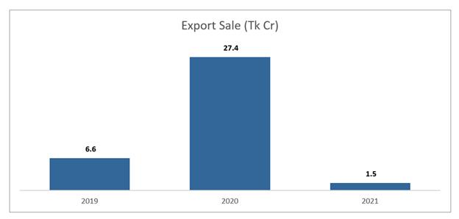

Threats:
Regulations and Laws:
Awareness about the health hazards and increasing number of regulations imposed by the government about smoking and selling cigarettes.
- Samiha Arefin

PESTLE Analysis
Political:
Regulatory controls (High taxes and duties):
In January 2025, the National Board of Revenue decided to increase the overall tax on cigarettes to 83% of the retail price, addressing concerns about public health (Singha, 2025).
BAT Bangladesh expressed its concern about this sudden hike, as Bangladesh pays one of the highest corporate taxes on tobacco in the world. This threatens the company’s sustainability, employment, and FDI(FinancialExpress,2025).

Economic:
Inflation:
BAT BD reported that in 2023 due to inflation their quarterly profit declined despite 15% growth in revenue. (Financial Express, 2023).
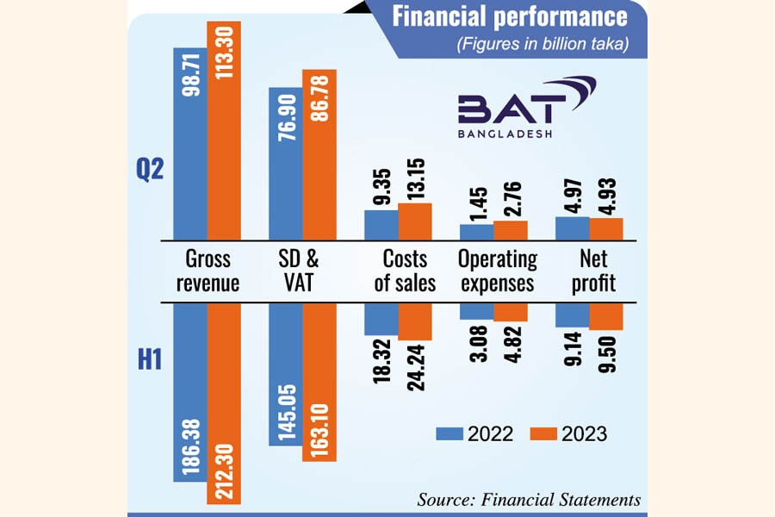

Production capacity and Exports:
BAT BD invested millions in manufacturing capacity to meet domestic demand and increase exports. In 2023 BAT BD made 9.35% of year-on-year profit as their exports were more than doubled. (Financial Express, 2023).
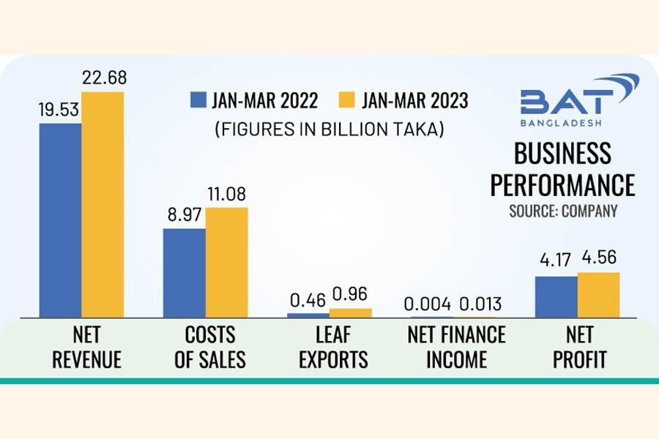

Social:
Social Norms:
Cultural permissiveness and gender norms in Bangladesh allows BAT to expand their market to male customers but this limits female consumption and public presence.

Social Pressures:
BAT has initiated several CSR projects like Bonayan, Proshar, Probaho along with youth education and although the beneficiaries support these programs health and policy experts find this contradictory and remains skeptical.
.

- Samiha Arefin
Technology:
BATBC is using advanced technology for reduction in logistics costs. BAT partnered with 4flow to optimize their work from farms to processing centers. Because of this the logistics cost was reduced by 24% and transparency was improved(Success Story BAT Bangladesh, n.d.). Moreover, advanced technologies are being used for robotic automation and smart infrastructure for more eco-friendly environment(British American Tobacco - It’s TIME to Talk Automation, n.d.).

Legal:

Since the end of 2024 interim government imposed new laws on selling loose cigarettes, vapes , and e-cigarettes which was a hard blow to the company. Along with that, health activists and social workers are asking lawmakers to impose more strict anti-tobacco regulations, making it more difficult for the company to run smoothly.(Global advocacy group calls for evidence‑based tobacco regulation in Bangladesh, 2025)

Environment:

One of the biggest downsides of tobacco cultivation is the deforestation in areas like the Chittagong Hill Tracts and water pollution because of pesticides. Local environment groups and activists are furious due to this. BAT promotes eco-friendly packaging, solar energy use, and zero waste policies, but people would argue that it falls short in comparison to the damage it’s causing(Tobacco – the Silent Environment Killer!, n.d.).

- Samin Tanzim Rahman

SWOT-Based Recommendations for BAT:

Strengths

Capitalize Geographic Diversification: Employees with multi-region operations to capitalize on high-growth emerging marketplaces.
Diversify Your Products: Employ broad diversities of products with fresh lower nicotine or smokeless technology.

Weakness

Lower Health Risks: Invest in harm reduction product development and corporate reputation enhancement through public health programs.
Avoid Legal and Regulatory Risks: Invest legal and compliance functions; perform effective lobbying and policy engagement.
Opportunity

Make investments for Mergers & Acquisitions: Invest in new-generation brands, start-ups from either a wellness or vaping category, for diversification.
Make Gains for Your Company through Low-Nicotine Cigarettes: Reach health-conscious consumers from new marketplaces through lower-risk cigarettes.
Threat

Reorient Around Evolving Consumer Tastes: transition from current-generation (traditional cigarettes) towards new-generation (vapor cigarettes, tobacco-containing snus-like pouches)
Comply with Green Laws: Produce going green and biodegradable packaging so that compliance can be met.

PESTLE-Based Recommendations for BAT:

Political
Get Governments on Side: Engage authorities to create tobacco policies that are aligned; advocate for taxation structures that enable harm reduction. To gain goodwill BAT also can Collab with international public health organizations to emerging markets
Economic
Diversify Income Streams: Diversify beyond base tobacco income through diversification of wellness, CBD, or drink platforms. BAT also can invest in wellness drinks and functional beverage.
Social
Reorient Marketing Strategies: Brand lower-risk products as lifestyle selections, not least for youth adult smokers switching to a culture of vape. BAT's public image can be improved by engaging in public health campaigns also supporting in smoking cessation and even collet fund for youth education. Mainly target 18-35 aged smokers and Collab with social influencers to promote in digital platform.
Technological
Make R&amp;D investments: Invest in intelligent vaping devices and heat-not-burn technology to be a first mover for alt nic devices. For developing eco friendly production and also waste reducing technologies by using R&D
Legal
Install Compliant Systems: Also, be ready for global anti-smoke legislation and plain packaging provisions, avoiding penalties. For managing different regulations across jurisdictions create a centralized compliance system.( e.g., Asia and EU)
Environment
Adopting Sustainable Models: Reduce supply chain footprints via the use of green packaging for garnering ESG-sensitive investors. By switching to renewable energy and reducing carbon emissions and investing in eco friendly logistics for local factories.
- Samira Sultana & Hazera Jahan Ratri

Conclusion

To sum up, BATBC is one of the largest in the FMCG sector in Bangladesh. Through its unique characteristics such as ownership structures, flexibility and its dedication for being a socially trusted business entity.
The company is also known for its social initiatives for which the CSR initiatives, company plays a crucial role in social and environmental development. After critically analyzing the findings, it is found that the company still has a chance to grow and flourish more through the extension of its socially and morally sustainable practices, by investing in the products that are of less harm and innovation, and by studying the various income sources. If such recommendations are executed, the company shall even grow big, become more rigid and will help for being more relevant so that it will be ethically accountable to the public by default.
- Chëñchö Tsħëřiñġ

References:
Anti-tobacco advocates criticize unchanged cigarette prices. (2025, June 2). Dhaka Tribune. https://www.dhakatribune.com/bangladesh/382950/anti-tobacco-advocates-criticize-unchanged

BAT Bangladesh. (2023). Annual report 2023. https://www.batbangladesh.com/
BAT Bangladesh. (2024). Sustainability and supply chain operations. https://www.batbangladesh.com/
BAT calls for embrace of smokeless products. (n.d.). The Daily Observer. https://www.observerbd.com/news/527857
Bangladesh takes massive step with historic tax and price increases of cigarette to follow FCTC. (2025, January 9). PublicHealth24. https://www.publichealth24.com/bd‑takes‑massive‑step‑with‑historic‑tax‑and‑price‑increases‑of‑cigarette‑to‑follow‑fctc/
British American Tobacco - home. (n.d.). https://www.bat.com/?fbclid=IwY2xjawLnAbZleHRuA2FlbQIxMQABHl2OsqR5SazCNEnTtvMxC EBRw-JKv_XTLFwyPS_EUqzy0diarOEff1s3PkIr_aem_y0i_r2fECL19ZLqqFrwEJw
British American Tobacco - It’s TIME to talk automation. (n.d.). https://www.bat.com/media/news-and-stories/_2021/november/it-s-time-to-talk-automation?
British American Tobacco Bangladesh Company Limited. (2023). Sustainability report 2023. https://www.batbangladesh.com/content/dam/endmarkets/bd/en/download/investors-and-reporting/sustainability-reporting/Sustainability-Report-2023.pdf
British American Tobacco Bangladesh Company Limited. (n.d.). Our corporate social responsibility. https://www.batbangladesh.com/sustainability-and-responsibility/our-corporate-social-responsibility
British American Tobacco Zimbabwe - About us. (n.d.). https://www.batzimbabwe.com/who-we-are/about-us
Dhaka Tribune. (2025, May 31). Activists urge stricter laws to curb tobacco-related deaths. https://www.dhakatribune.com/bangladesh/2025/05/31/activists-urge-stricter-laws-to-curb-tobacco-related-deaths
Desk, T. (2025, June 2). Anti-tobacco advocates criticize unchanged cigarette prices. Dhaka Tribune. https://www.dhakatribune.com/bangladesh/382950/anti-tobacco-advocates-criticize-unchanged
Financial Express. (2022, November 10). Tobacco firms dominate rural markets with cheaper brands. The Financial Express. https://thefinancialexpress.com.bd/trade/tobacco-firms-dominate-rural-markets-with-cheaper-brands-1668072125

Global advocacy group calls for evidence‑based tobacco regulation in Bangladesh. (2025, February 17). The Financial Express. https://thefinancialexpress.com.bd/national/wai-calls-for-evidence-based-tobacco-regulation-in-bangladesh
Issue-I, S. A. (2022, April 1). BATBC to invest above Tk 5.74b. The Financial Express. https://thefinancialexpress.com.bd/stock/bangladesh/batbc-to-invest-above-tk-574b-164878416 3
Issue-I, S. A. (2023, July 25). Quarterly profit of BAT Bangladesh declines despite higher revenue. The Financial Express. https://thefinancialexpress.com.bd/stock/bangladesh/quarterly-profit-of-bat-bangladesh-declines-despite-higher-revenue
LightCastle Partners. (2021, June 15). The tobacco industry in Bangladesh: A closer look. https://www.lightcastlebd.com/insights/2021/06/the-tobacco-industry-in-bangladesh-a-closer-look/
Markedium. (2022, April 30). Exploring The Potential | BATBC's Newly Focused Export Market | Markedium. https://markedium.com/exploring-the-potential-batbcs-newly-focused-export-market/
Rahman, W. (2021, February 17). BATBC eyeing export market. Dhaka Tribune. https://www.dhakatribune.com/business/238873/batbc-eyeing-export-market
Success story BAT Bangladesh. (n.d.). https://www.4flow.com/success-stories/bat-bangladesh?
The Business Standard. (2024a, December 20). BATBC evaded Tk379cr VAT over four years: NBR. https://www.tbsnews.net/economy/batbc-evaded-tk379cr-vat-over-four-years-nbr-766210
The Business Standard. (2024a, December 25). BAT Bangladesh to invest Tk28cr for capacity expansion. https://www.tbsnews.net/economy/corporates/bat-bangladesh-invest-tk28cr-capacity-expansion-768986
The Business Standard. (2024b, October 6). Govt eyes new ordinance to curb tobacco use, BAT protests. https://www.tbsnews.net/bangladesh/health/govt-eyes-new-ordinance-curb-tobacco-use-bat-protests-715874
The Financial Express. (n.d.). BAT's profit rises over 9pc on higher leaf export. https://today.thefinancialexpress.com.bd/stock-corporate/bats-profit-rises-over-9pc-on-higher-leaf-export-
Tobacco – the silent environment killer! (n.d.). Bangladesh Post. https://bangladeshpost.net/posts/tobacco-the-silent-environment-killer-86646
Tobacco Atlas. (2022). Tobacco use in Bangladesh. https://tobaccoatlas.org/country/bangladesh/
Tobacco industry seeks long‑term fiscal roadmap. (2025, February 12). The Financial Express. https://thefinancialexpress.com.bd/trade/tobacco-industry-seeks-long-term-fiscal-roadmap
World Health Organization. (2022). Tobacco and its environmental impact: An overview. https://www.who.int/publications/i/item/9789240039949

